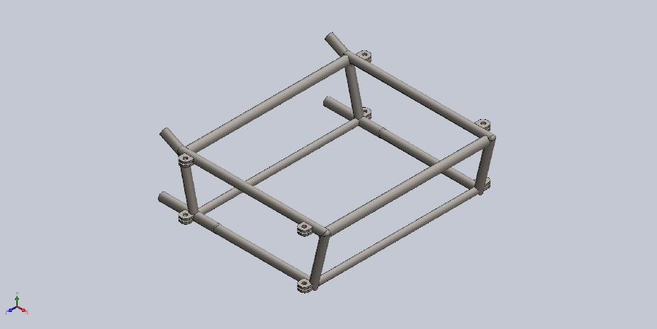 | Simulation of AutoRecover Of ShelledModel1  Date: March 30, 2023  Designer: Solidworks  Study name: Static 5  Analysis type: Static  Table of Contents  Description 1  Assumptions 2  Model Information 2  Study Properties 3  Units 3  Material Properties 4  Loads and Fixtures 5  Connector Definitions 6  Contact Information 6  Mesh information 7  Sensor Details 8  Resultant Forces 8  Beams 8  Study Results 9  Conclusion 11

Description
Torsional Forces Analysis. Torsional Forces were applied along all 4 columns to simulate the forces the subframe would typically experience

Assumptions

Model Information

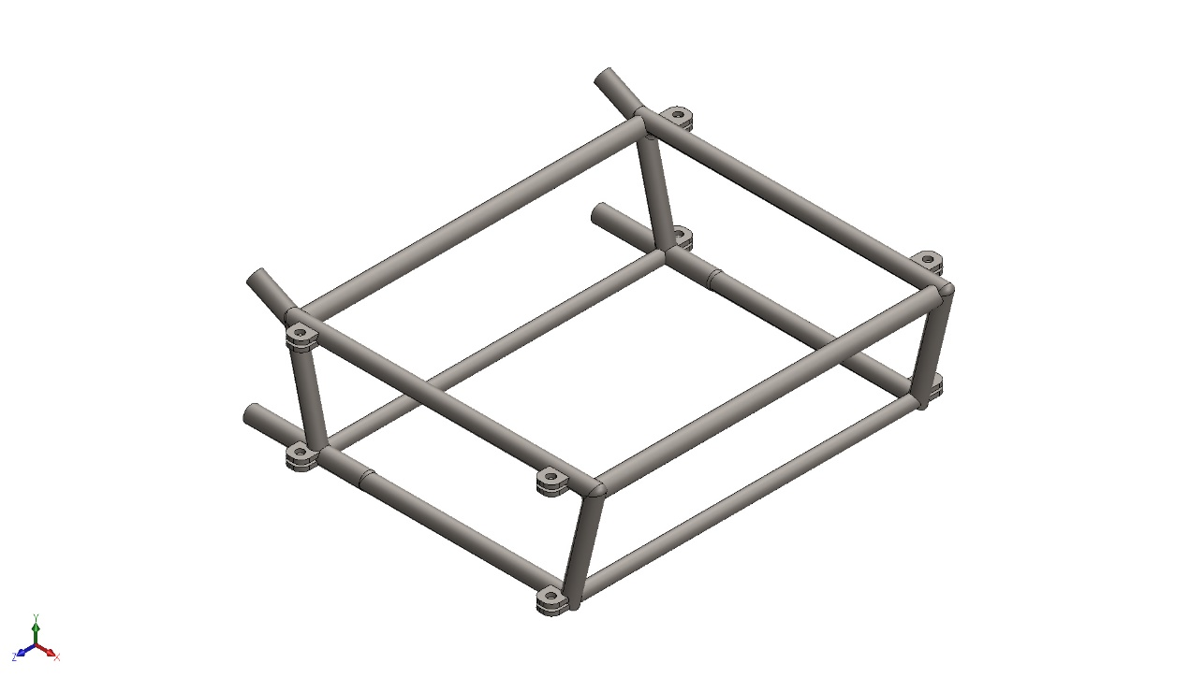
Model name: AutoRecover Of ShelledModel1
Current Configuration: Default
Solid Bodies
Document Name and Reference | Treated As | Volumetric Properties | Document Path/Date Modified
Mirror4  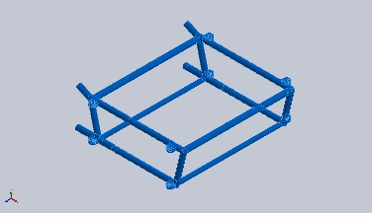 | Solid Body | Mass:3.3 kg  Volume:0.00111137 m^3  Density:7,847.94 kg/m^3  Weight:32.24 N | C:\Users\westy\OneDrive\Documents\SubFrame Documents\Frame_Documents\ShelledModel1.SLDPRT  Mar 30 11:46:53 2023

Study Properties
Study name | Static 5
Analysis type | Static
Mesh type | Solid Mesh
Thermal Effect: | On
Thermal option | Include temperature loads
Zero strain temperature | 298 Kelvin
Include fluid pressure effects from SOLIDWORKS Flow Simulation | Off
Solver type | FFEPlus
Inplane Effect: | Off
Soft Spring: | Off
Inertial Relief: | Off
Incompatible bonding options | Automatic
Large displacement | Off
Compute free body forces | On
Friction | Off
Use Adaptive Method: | Off
Result folder | SOLIDWORKS document (C:\Users\westy\OneDrive\Documents\SubFrame Documents\Frame_Documents)

Units
Unit system: | SI (MKS)
Length/Displacement | mm
Temperature | Kelvin
Angular velocity | Rad/sec
Pressure/Stress | N/mm^2 (MPa)

Material Properties
Model Reference | Properties | Components
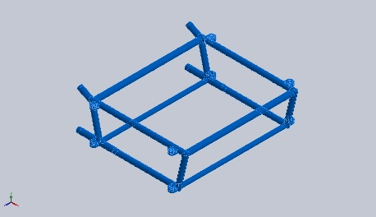 | Name: AISI 4130 Steel, normalized at 870C  Model type: Linear Elastic Isotropic  Default failure criterion: Unknown  Yield strength: 460 N/mm^2  Tensile strength: 731 N/mm^2  Elastic modulus: 205,000 N/mm^2  Poisson's ratio: 0.285  Mass density: 7.85 g/cm^3  Shear modulus: 80,000 N/mm^2 | SolidBody 1(Mirror4)(AutoRecover Of ShelledModel1)
Curve Data:N/A

Loads and Fixtures
Fixture name | Fixture Image | Fixture Details
Fixed-1 | 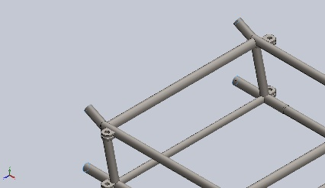 | Entities: 4 face(s)  Type: Fixed Geometry
Resultant Forces
Components | X | Y | Z | Resultant
Reaction force(N) | -0.20706 | 0.00578785 | -14.8168 | 14.8183
Reaction Moment(N.m) | 0 | 0 | 0 | 0

Load name | Load Image | Load Details
Torque-1 | 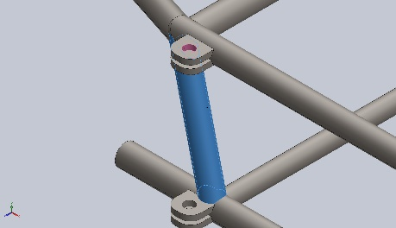 | Entities: 1 face(s)  Reference: Face< 1 >  Type: Apply torque  Value: 1 N.m
Torque-2 | 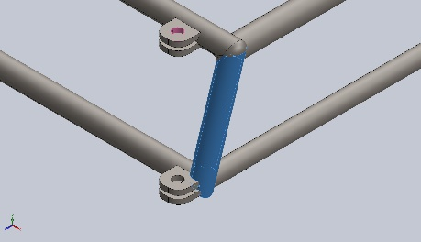 | Entities: 1 face(s)  Reference: Face< 1 >  Type: Apply torque  Value: 1 N.m
Torque-3 | 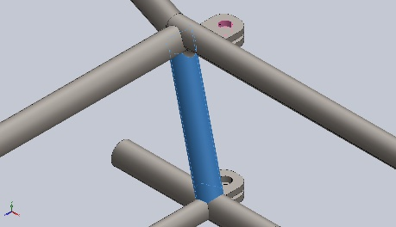 | Entities: 1 face(s)  Reference: Face< 1 >  Type: Apply torque  Value: 1 N.m
Torque-4 | 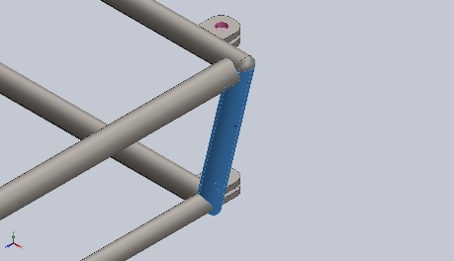 | Entities: 1 face(s)  Reference: Face< 1 >  Type: Apply torque  Value: 1 N.m

Connector Definitions
No Data

Contact Information
No Data

Mesh information
Mesh type | Solid Mesh
Mesher Used: | Standard mesh
Automatic Transition: | Off
Include Mesh Auto Loops: | Off
Jacobian points for High quality mesh | 16 Points
Element Size | 10.361 mm
Tolerance | 0.518051 mm
Mesh Quality | High

Mesh information - Details
Total Nodes | 21826
Total Elements | 11009
Maximum Aspect Ratio | 19.259
% of elements with Aspect Ratio < 3 | 92.8
Percentage of elements with Aspect Ratio > 10 | 0.109
Percentage of distorted elements | 0
Time to complete mesh(hh;mm;ss): | 00:00:04
Computer name: | JOSH-G15
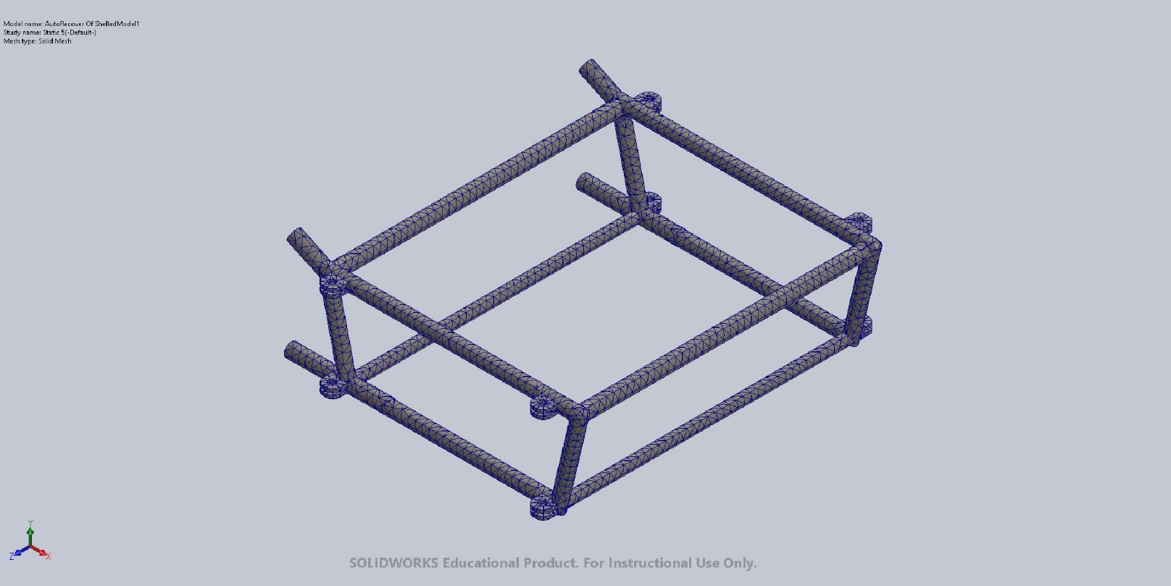

Sensor Details
No Data

Resultant Forces

Reaction forces
Selection set | Units | Sum X | Sum Y | Sum Z | Resultant
Entire Model | N | -0.20706 | 0.00578785 | -14.8168 | 14.8183

Reaction Moments
Selection set | Units | Sum X | Sum Y | Sum Z | Resultant
Entire Model | N.m | 0 | 0 | 0 | 0

Free body forces
Selection set | Units | Sum X | Sum Y | Sum Z | Resultant
Entire Model | N | 0.0245838 | 0.0809659 | 0.0185621 | 0.0866279

Free body moments
Selection set | Units | Sum X | Sum Y | Sum Z | Resultant
Entire Model | N.m | 0 | 0 | 0 | 1e-33

Beams
No Data

Study Results

Name | Type | Min | Max
Stress1 | VON: von Mises Stress | 4.024e-03N/mm^2 (MPa)  Node: 9597 | 4.298e+00N/mm^2 (MPa)  Node: 18244
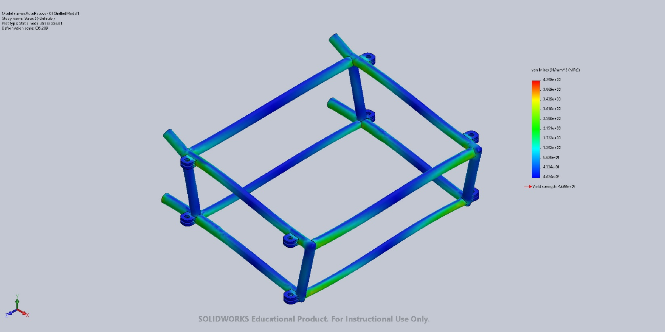
AutoRecover Of ShelledModel1-Static 5-Stress-Stress1

Name | Type | Min | Max
Displacement1 | URES: Resultant Displacement | 0.000e+00mm  Node: 259 | 5.889e-02mm  Node: 18935
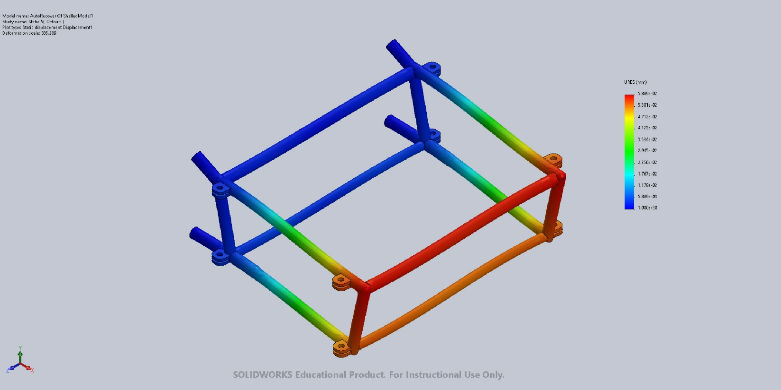
AutoRecover Of ShelledModel1-Static 5-Displacement-Displacement1

Name | Type | Min | Max
Strain1 | ESTRN: Equivalent Strain | 8.030e-08  Element: 9586 | 1.216e-05  Element: 2861
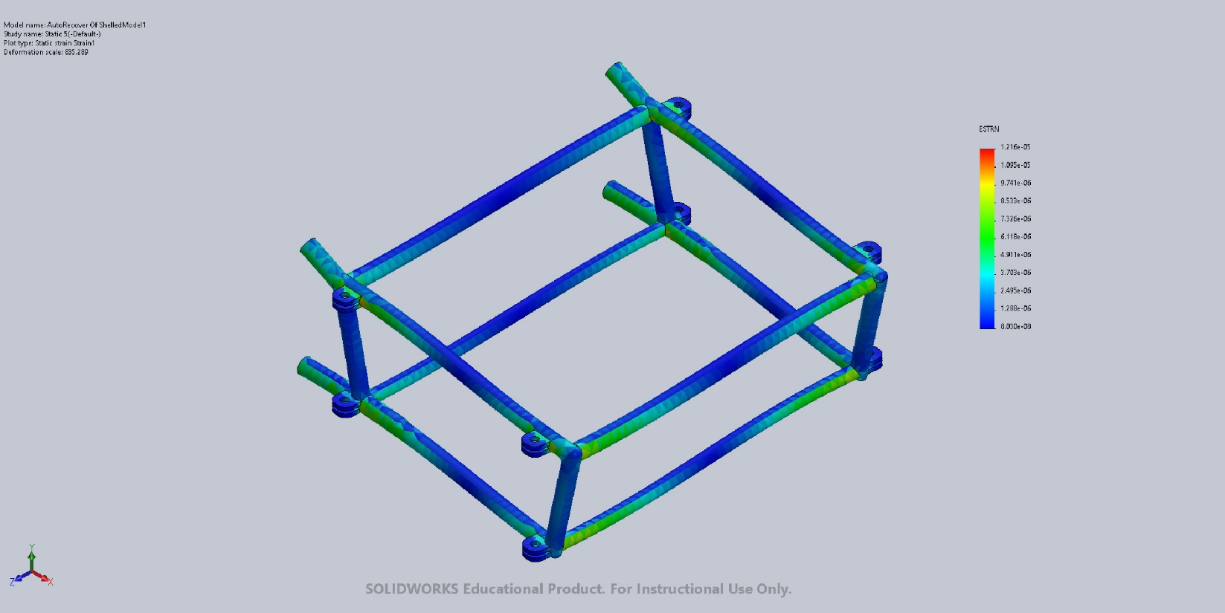
AutoRecover Of ShelledModel1-Static 5-Strain-Strain1

Name | Type
Displacement1{1} | Deformed shape
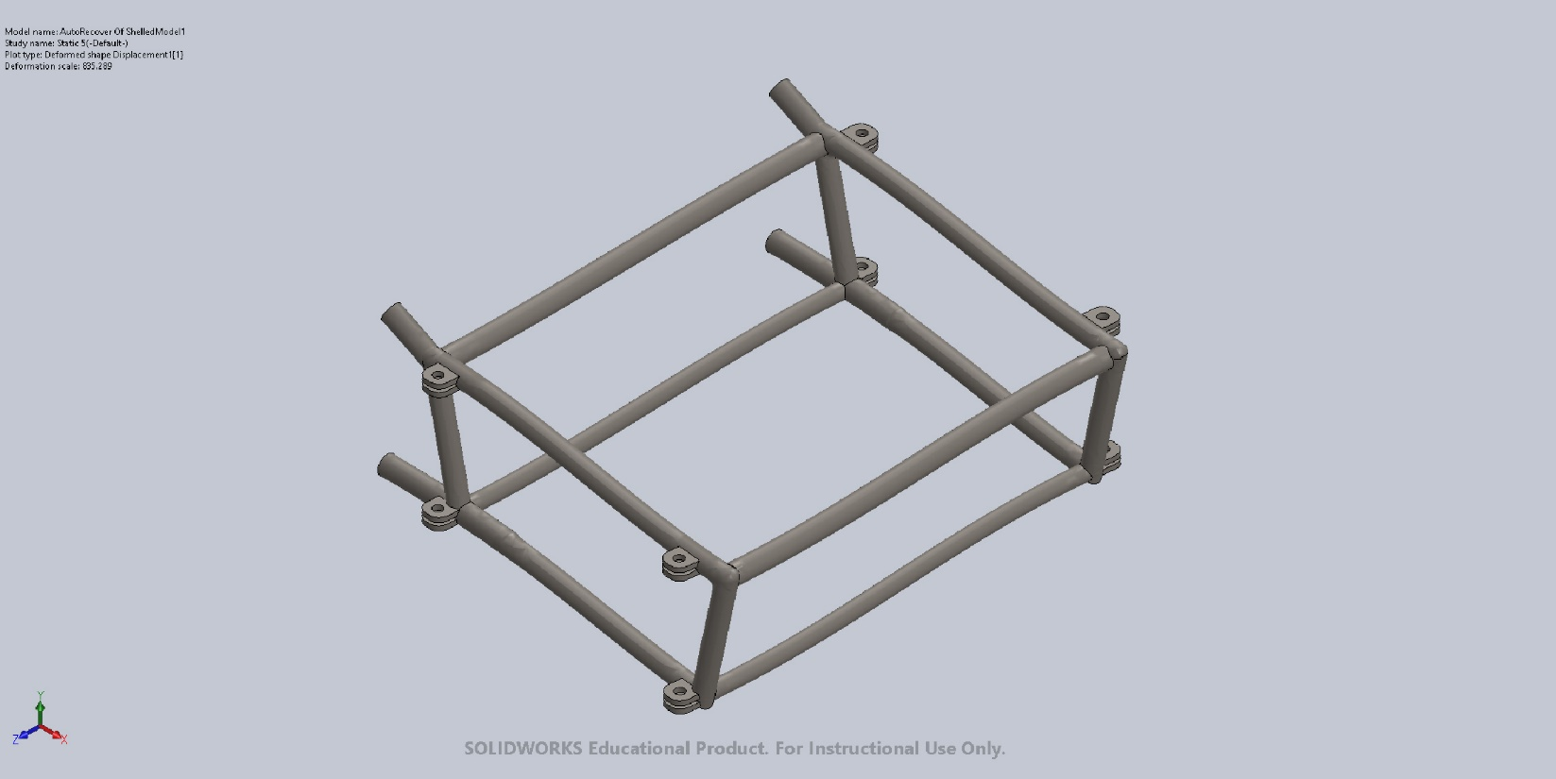
AutoRecover Of ShelledModel1-Static 5-Displacement-Displacement1{1}

Conclusion

